1. EXECUTIVE SUMMARY
This technical laboratory report demonstrates how the native architecture of the Windows NTFS file system can be utilized to hide data or executables behind a legitimate file structure. This capability, known as Alternate Data Streams (ADS), is classified under the MITRE ATT&CK framework as a Defense Evasion (T1564.004) technique.
The scope of this laboratory is divided into three practical phases:
- Simulating an attacker scenario by embedding a hidden data stream into a benign text file using PowerShell.
- Verifying the invisibility of the hidden payload through standard Windows graphical user interfaces (GUI).
- Utilizing Blue Team forensic methodology to detect, isolate, and extract the hidden binary layer.

2. PHASE 1: ATTACK SIMULATION & STREAM CREATION
In the NTFS file system, files possess a default primary data stream designated as :$DATA, which holds the visible content. Adversaries leverage the colon (:) separator to forge secondary, hidden allocation channels without altering the visible presentation of the file.
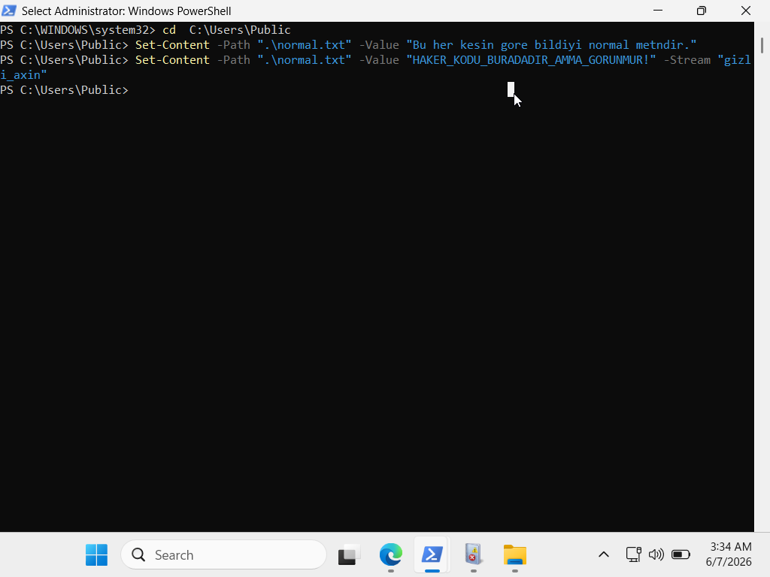
To bypass strict environment syntax barriers regarding path styling, the official Windows PowerShell -Stream parameter was deployed to establish the alternate data layer directly within a safe public environment.

3. PHASE 2: EVASION & INVISIBILITY VERIFICATION
Standard administrative tools, such as Windows File Explorer and Notepad, are hardcoded to interact solely with the primary :$DATA allocation stream. As a consequence, the newly injected :gizli_axin stream remains completely hidden from casual view. Furthermore, the physical file size reported by the OS properties does not reflect the added hidden payload, granting the adversary absolute stealth.
Verification Step: Opening the file via File Explorer and default Notepad displays only the benign text stream.
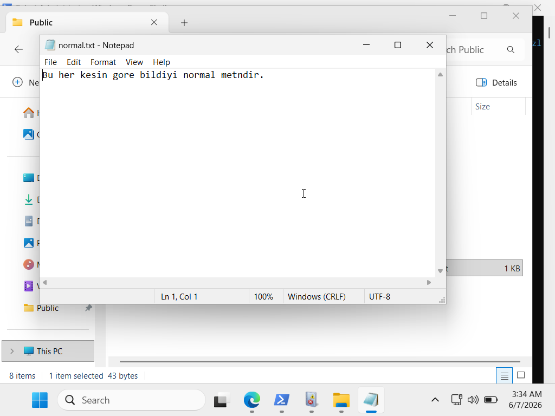
Graphical Evidence: The screenshot below demonstrates that the hidden string is completely absent from the standard user view and Notepad interface.

4. PHASE 3: FORENSIC DISCOVERY & EXTRACTION (BLUE TEAM)
From a Security Operations Center (SOC) standpoint, uncovering Alternate Data Streams requires low-level evaluation of file metadata. Standard directory listing commands fail, meaning an analyst must request the raw streams directly from the NTFS engine.

4.1. Identifying the Hidden Streams
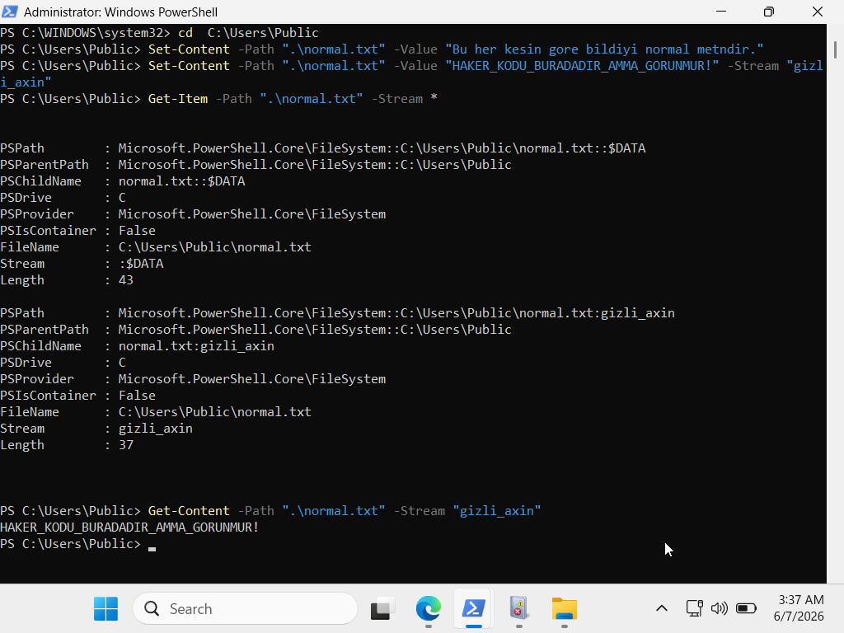
The Get-Item cmdlet paired with the -Stream * wild-card parameter was used to thoroughly audit the file's allocation blocks.

The output clearly segregates the standard payload from the hidden anomaly, confirming the presence of an unauthorized alternate stream named gizli_axin.
Once mapped, the internal string of the hidden stream was successfully dumped onto the terminal using the forensic extraction command:
Get-Content -Path ".\normal.txt" -Stream "gizli_axin"

5. SECURITY CONCLUSION & MITIGATION
- Least Privilege Access: Restricting write permissions on critical directories prevents standard users or compromised accounts from creating custom hidden streams on system binaries.
- Telemetry and Auditing: Enterprise environments should monitor Sysmon Event ID 15 (FileCreateStreamHash). This event explicitly logs whenever a new alternate data stream is created, capturing the hash of the hidden payload.
- Inherent OS Usage: It is critical to recognize that Windows natively uses this mechanism (specifically the :Zone.Identifier stream) to tag files downloaded from untrusted web zones. This laboratory successfully illustrates how a defensive feature can be mimicked for offense, and how defensive analysts can effectively uncover it.

